Plata, Abigail

ENG 180 - 03L

October 25, 2017

Lab 3: Working with Raster Data with ArcGIS

1.1 Introduction

Recently California has undergone a major drought where many rivers, reservoirs, and lakes were drying out. In Merced county there is a lot of agriculture which means the water demand is large due to the demand for food. A topography map of Merced is ideal for growing crops because it provides information to farmers about where the nearest streams are, how dry the land is, and any land cover type.

1.2 Methods

First, we began by making raster data in a spreadsheet. The GTopo30, California, clip, csv file is then selected to convert all the cells into a color according to the value in it. Using the spreadsheet raster data, we combine it with a GeoTiff, county polygon, and the osm shapefile in order to produce a map depicting the Yosemite National park polygon over the raster Digital Elevation Model. The next step is the raster to vector conversions. In this section the pixels will represent categorical variables like land cover type. Beginning with the i15 Crop Mapping shapefile, we then use the Project (Data Management) tool in ArcMaps to change the county layer to match the previous shapefile. Afterwards we extract the Merced county boundary from the projected California boundaries. Using the Clip (Analysis) tool we then clip the crop cover of the shapefile and produce the i15 crop merced shapefile. Next is rasterizing the polygons, where we will convert the vector landcover dataset to a raster. Using the Polygon to Raster tool provided through ArcMaps we can now use the i15 crop merced shapefile to convert it into a raster. We use the Crop2014 for the landcover category. Depending on the cell size we then produce the raster of that cell size. Afterward we summarized the area column of the Merced clip by landcover class, Crop2014 and produced a excel file of i15 merced crop summary. Then we begin summarizing the raster areas according to cell size. Finally using the two excel files we calculate the difference between shape areas and raster areas in hectares using X -meter pixels to produce a bar graph.

In the second portion of this lab we focused on raster manipulation, spatial operations with raster data, and the raster calculator. Beginning with raster manipulation, first we used the Clip (Data Management) tool to crop the GTOPO30 tiff raster to the extent of the Yosemite NP boundary and produced the GTOPO30 Yosemite crop. Secondly, we did these steps again, except this time made sure “Use Input Features for Clipping Geometry’ is checked which then produced the GTOPO30 Yosemite mask. In the spatial operations with raster data section we begin by using the Reclassify (Spatial Analysis) tool to replace a value in a raster to another value according to a ruleset or criterium. The ned2013_ mcd_mrp raster is the input, reclass field is set at value, and running the reclassify with ten classes defined by quantiles. We then rerun reclassify but with equal intervals of 500 meters. This produces ned13_15quant and need13_500m. Next we used the Contour (Spatial Analyst) tool in order to display images of quantitative depictions of relief. We used the NED2013_mcd_mrp_albers.tiff file as the input and under “output polyline features” we name the output file to be ned13_c500m.shp, and set the contour interval to 500 meters. Moving onto the Slope tool, which computes the slope of the terrain at a given pixel, from the surrounding pixels, we use the same NED2013_mcd_mrp_albers.tiff as the input and output ned13_slope. When one adjusts the transparency levels of these files it then begins to look like a terrain map. Moving onto the Aspect tool which computes the direction of the slope. After using the aspect tool the map looks like a terrain map. Finally in the raster calculator section, we demonstrate the hillshade tool that is used to produce shaded relief by using the raster calculator. The raster calculator allows you to calculate an algebraic expression on a cell-wise basis across a raster. The following expression is what was used in this lab, *Hillshade = 255.0*(cos(Zenith Radian)*cos(Slope Radian ))+(sin(Zenith Radian)*sin(Slope Radian)*cos(Azimuth Radian - Aspect Radian))*, where zenith equals the angle of the illumination source, above the horizon, and azimuth equals the azimuth of the illumination source. Opening the raster calculator in ArcMaps we then input this expression and produce ned_13_hillshade_rc. Now using the hillshade tool we use NED2013_mcd_mrp_albers.tiff as the input, check the box for model shadows, produce ned13_hillshade_1, turn off all layers except the original Digital Elevation Model, and turn the transparency to 75%. Tying all the previous elements together we now have a topographic map with 500 meter contours and 500 meter color classification.

In the third and final portion of this lab we now go into advanced terrain analysis in ArcGIS. At the end of this section one should understand how to use terrain and the Spatial Analyst toolbox to determine how water flows within a region. Beginning with calculating the flow direction of every pixel in our study region. Using the Flow Direction tool to produce a flow direction raster using the NED2013 DEM as an input. Next is the Flow Accumulation which computes the number of cells that drain into a particular cell. Using the Flow Direction raster for the input we then produce a NED_FlowAcc map. Now, using the flow accumulation raster and the raster calculator we then set cells to NULL if their value is less than 100,000 and make Ned_StreamNet. Then the Stream Link tool assigns unique values to links between junctions. Using the stream network and flow direction rasters, we generate a labeled stream network. The stream order then assigns orders to links in stream networks with either the Strahler or Shreve method. In this lab we use the Strahler method and use the Stream Order tool to produce the ned_StrmOrder map. Once completed with everything we can now create our final topographic map, Topo_Hydro_map, with the legend, pole directions, and scale.

1.3 Results and Discussion

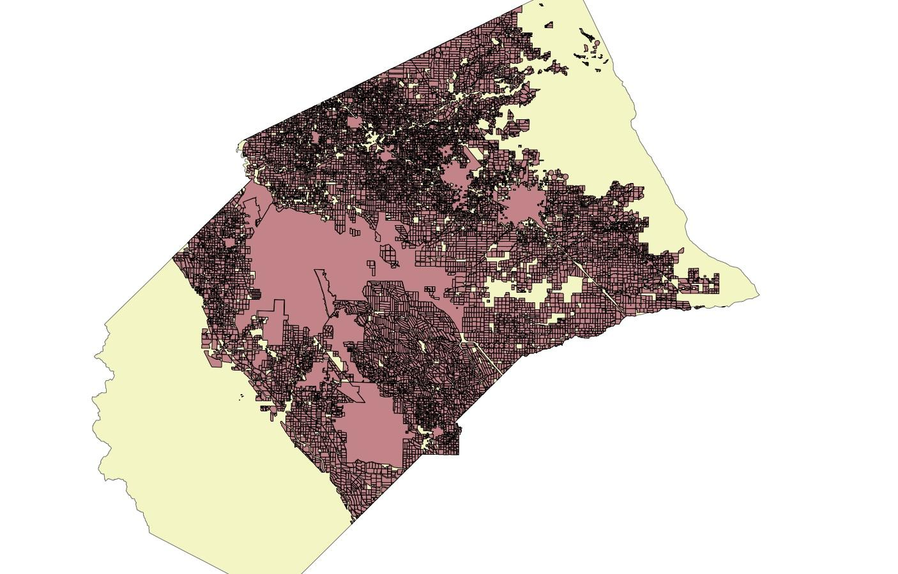

Vector to Raster Conversion

Merced county clipped and displaying the vector to raster conversions.

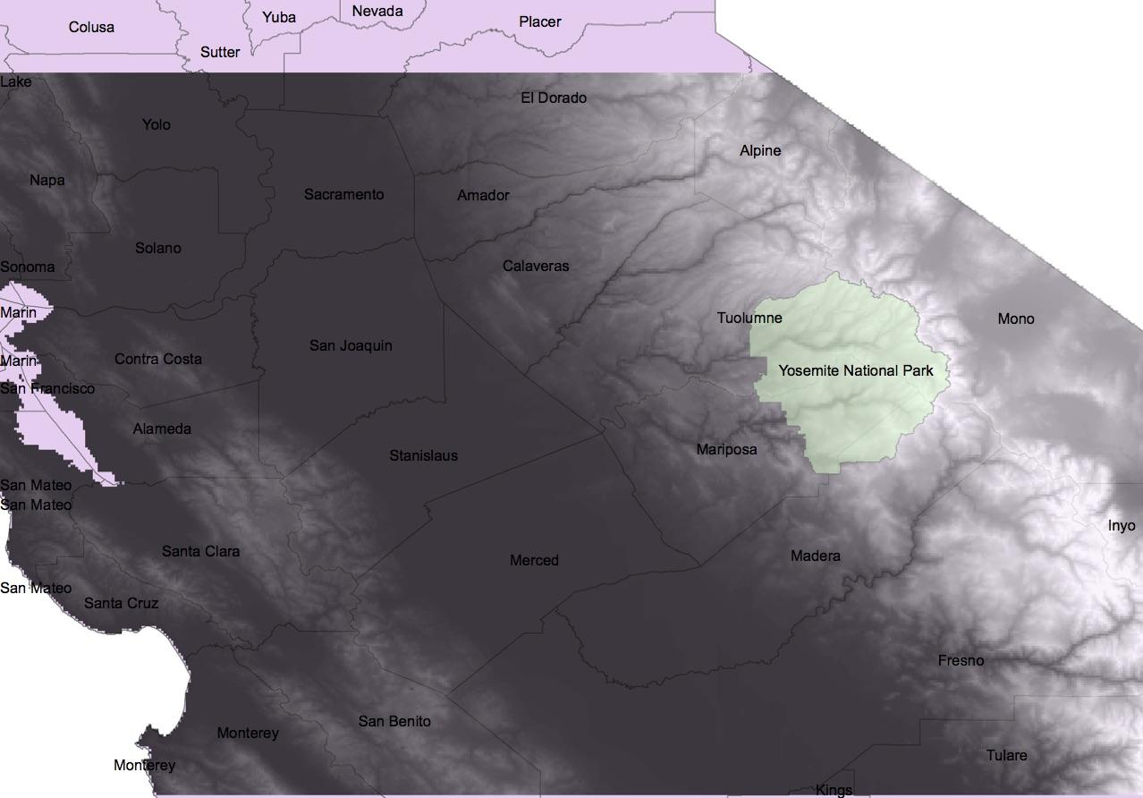

Raster Data Map

This map is displaying the raster data from excel where every cell has a value and depicts information according to the value.

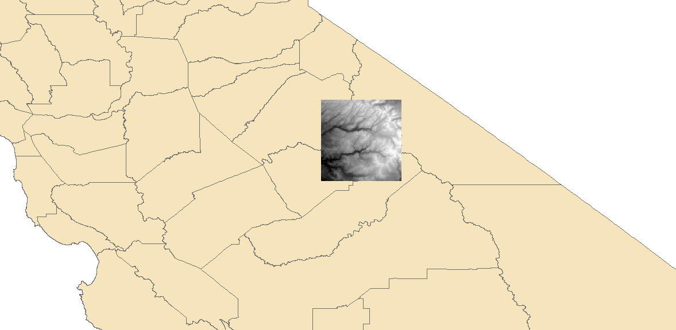

Gtopo30_ynp_crop

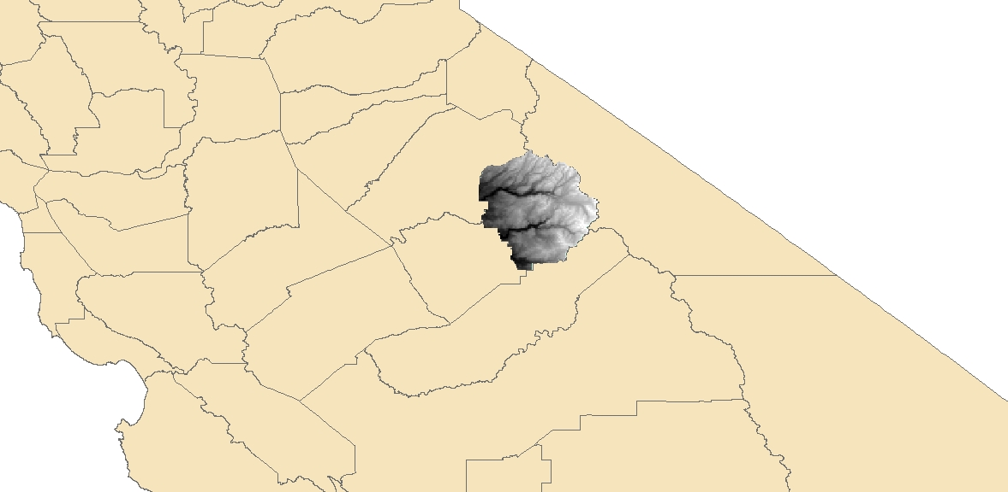

GTOPO30_YNP_mask

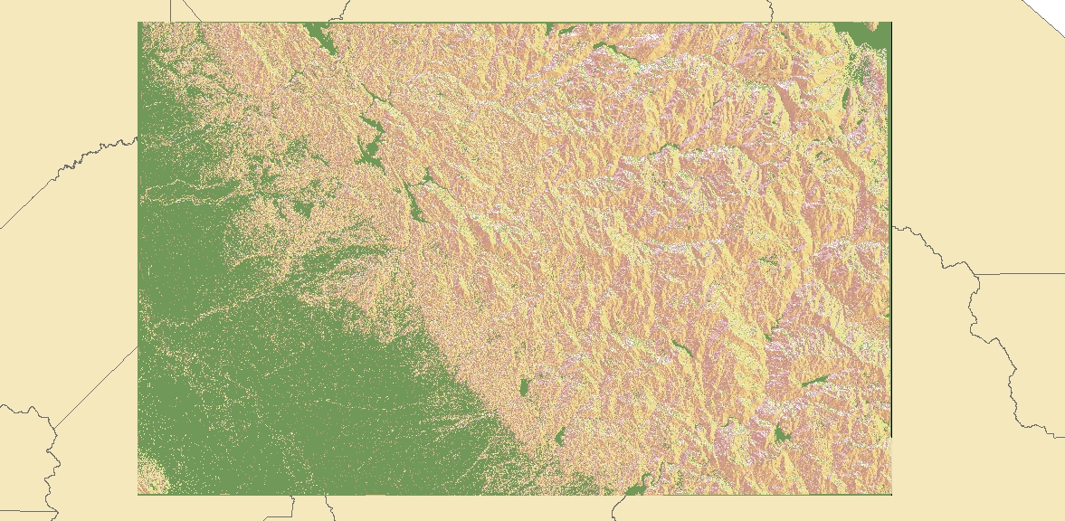

Terrain Map

The overall terrain map after inputting every different raster manipulation file.

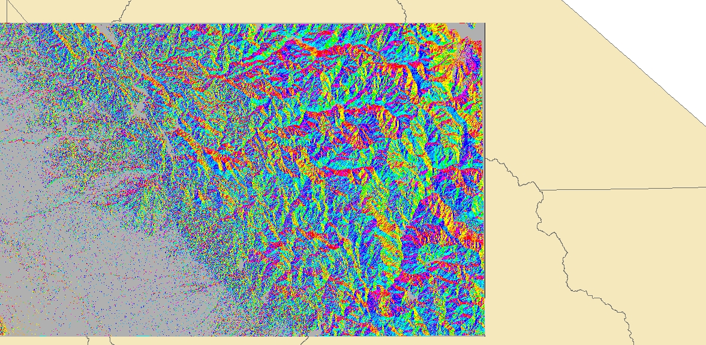

Ned13_500m

This map is produced after the reclassify manipulation tool with equal intervals of 500 meter.

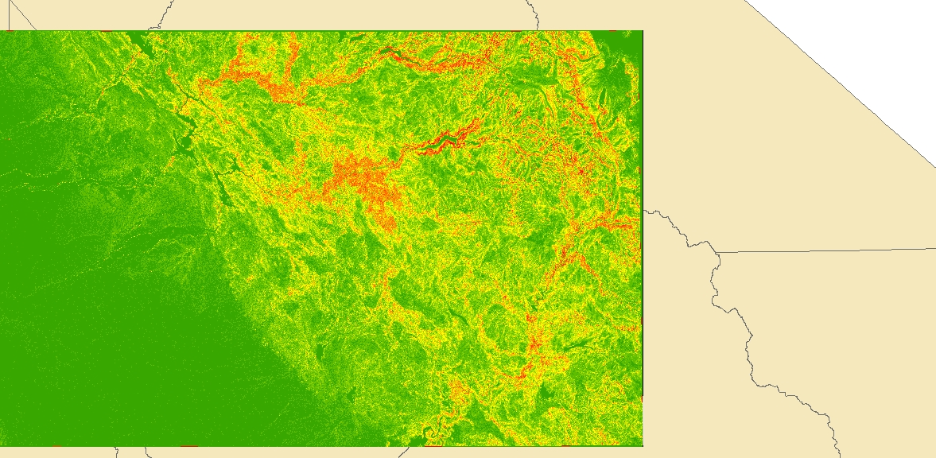

Ned13_Slope

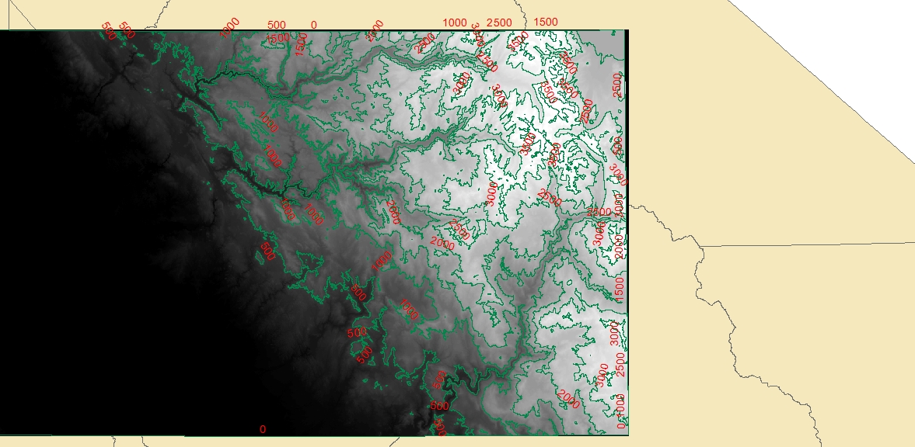

Ned13_c500m

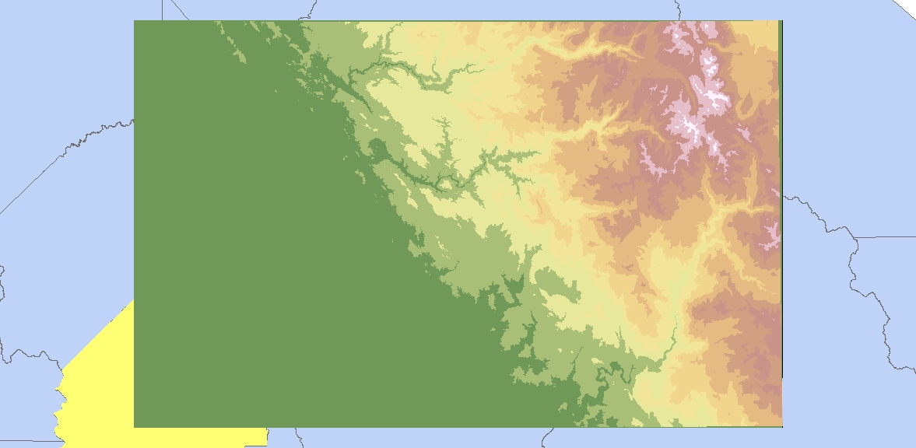

ned 13_500m

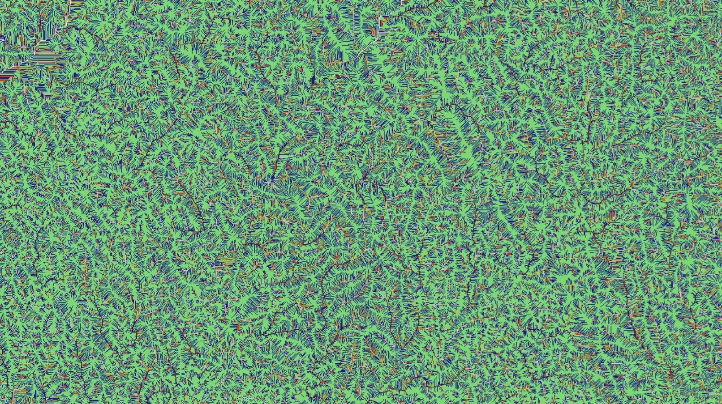

ned_StrmOrdH



Ned_StrmLnk

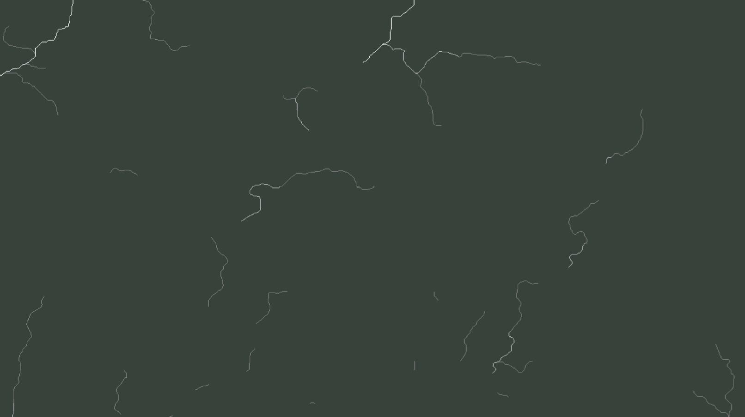

Ned_StreamNet

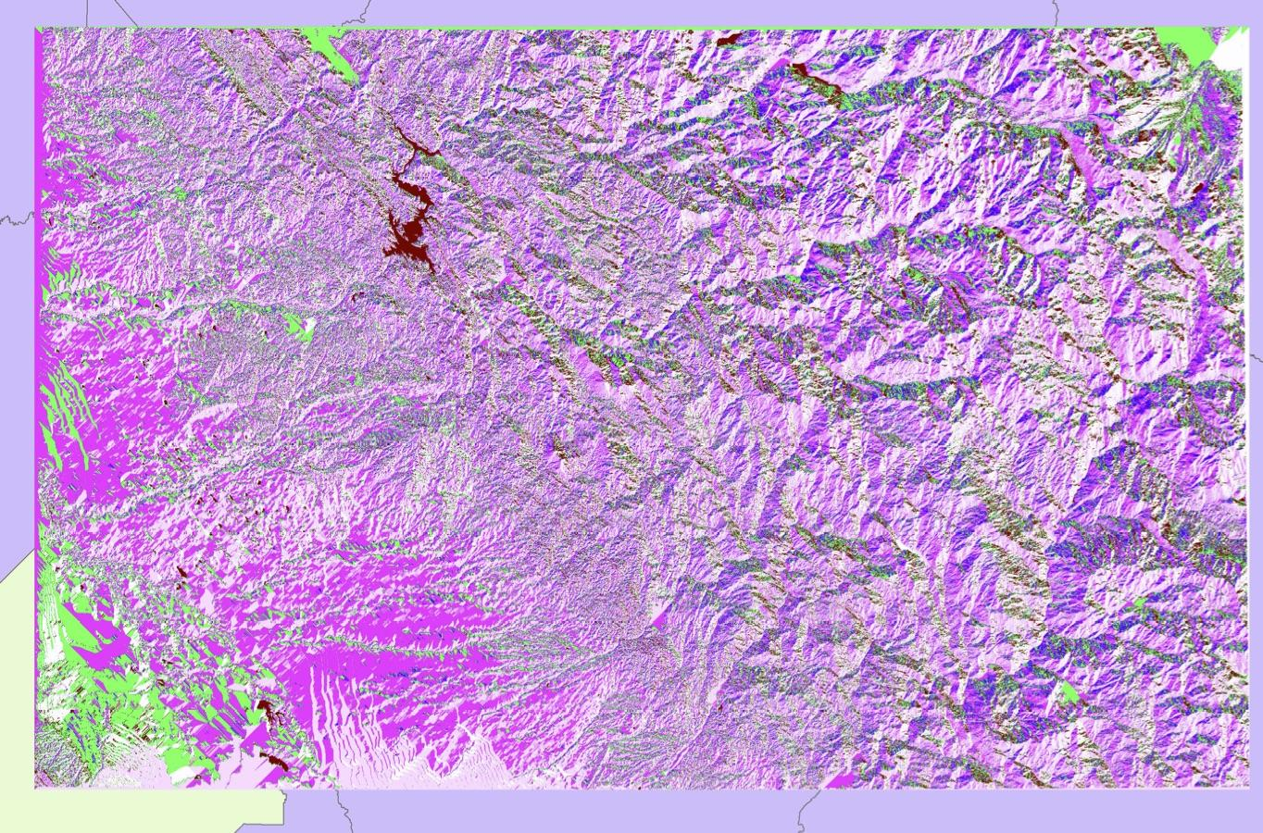

Ned_FlowDir



Ned_FlowAcc

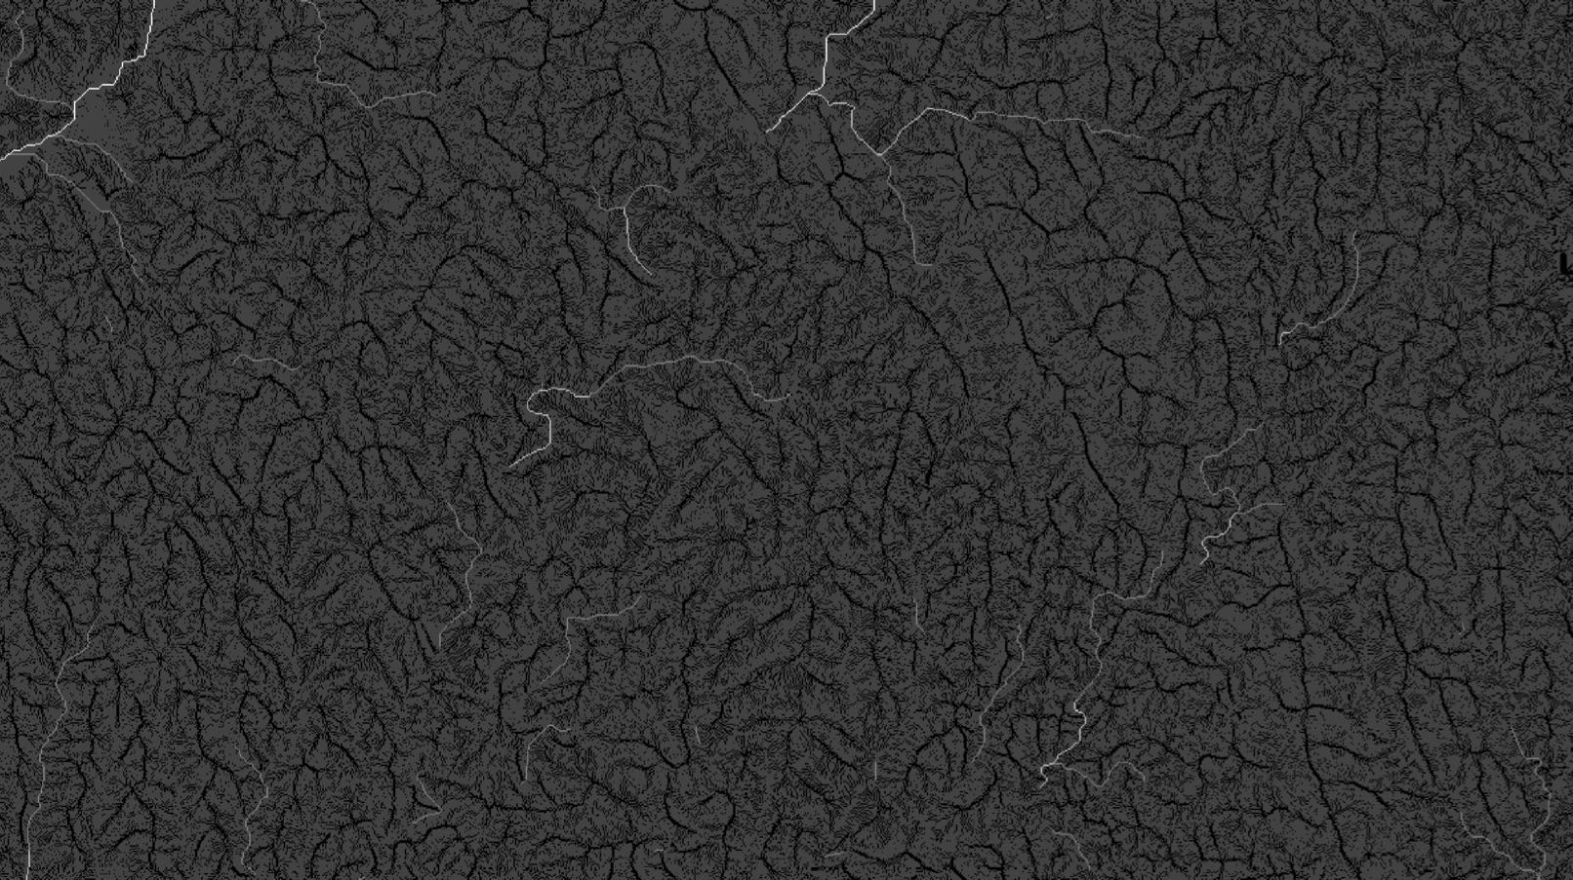

Flow Accumuliation

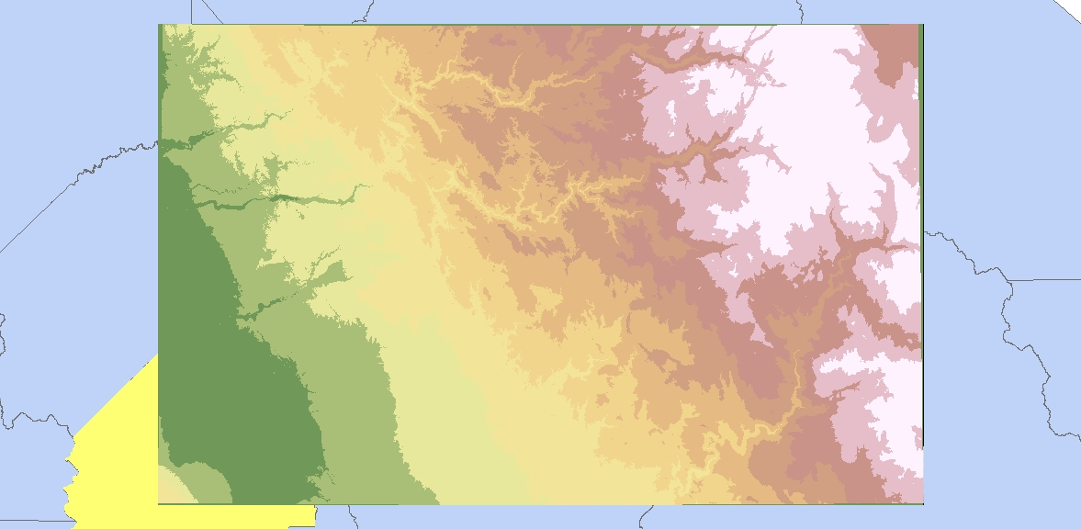

Ned13_15quant

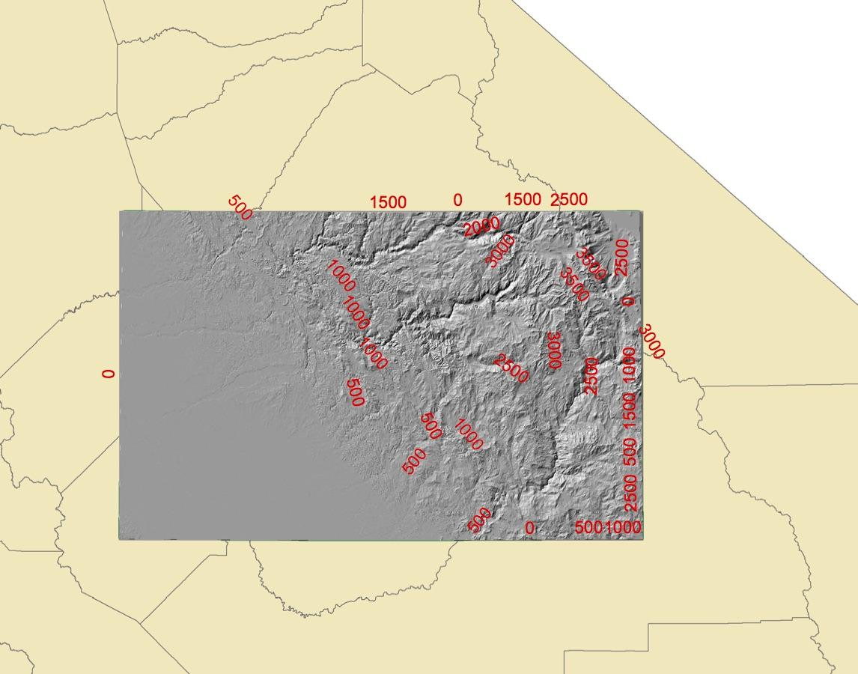

Topo map

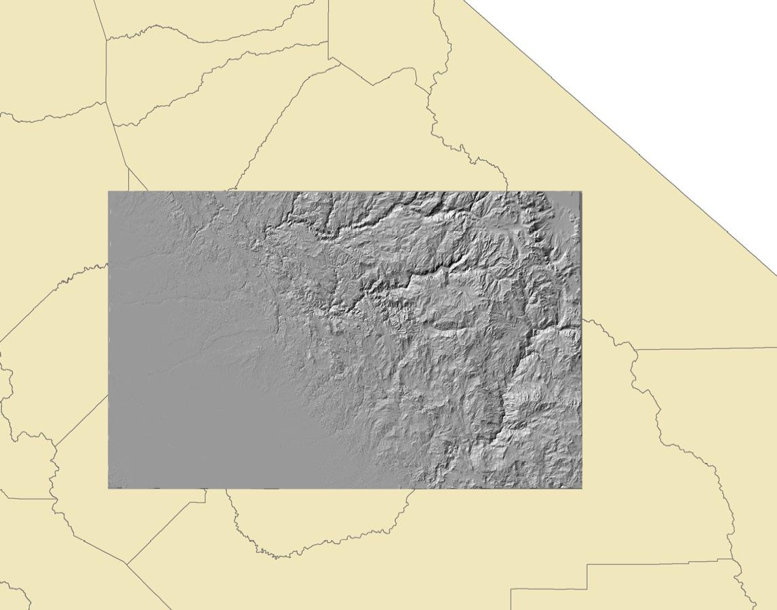

Hillshade

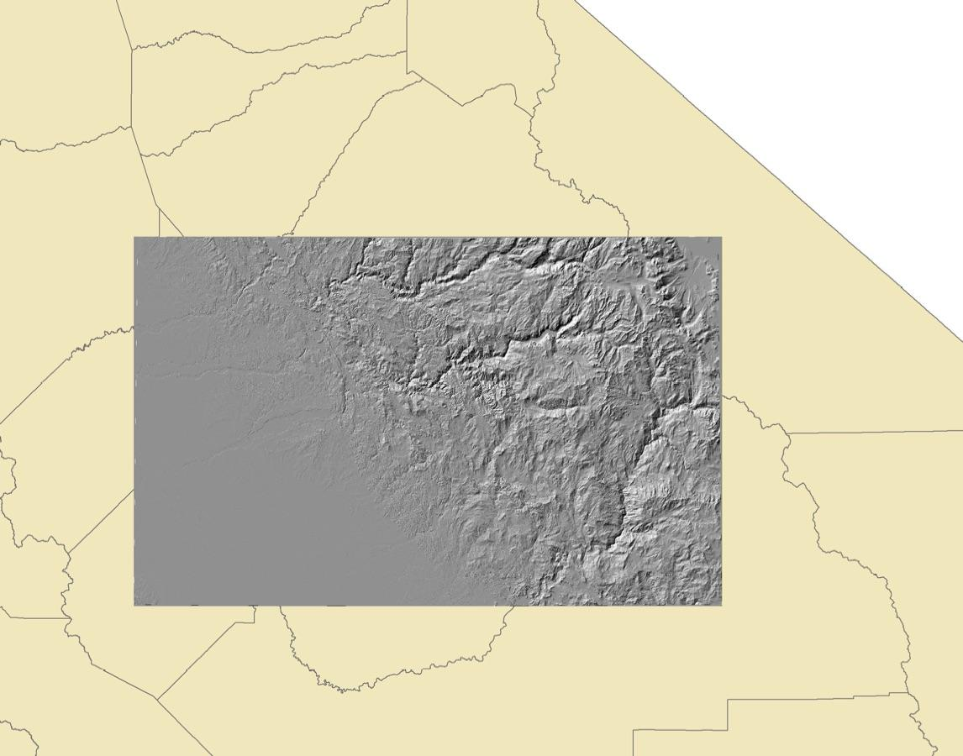

Hillshade Using the Raster Calculator